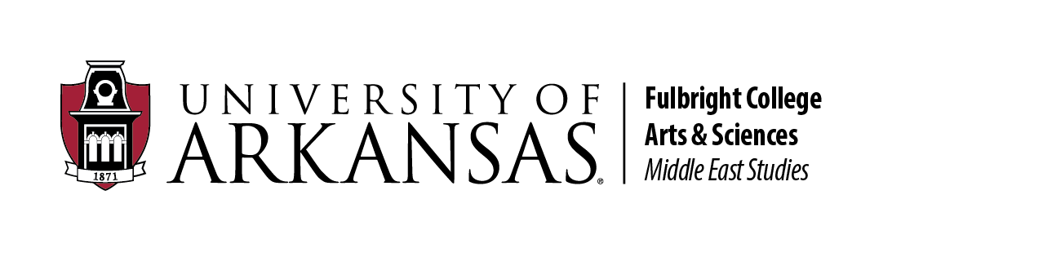
MEST Sponsorship & Co-Sponsorship Request Form
Applications are accepted on a rolling basis and should be submitted at least 6–8 weeks before the event date. Completed forms may be submitted electronically to mest@uark.edu.

Applicant Information
Name: __________________________________________________________________
Department / Organization: __________________________________________
University Affiliation: _________________________________________________
Email: ___________________________________________________________________
Phone :___________________________________________________________________
Status (Faculty / Staff / Graduate Student / Undergraduate / External): __________________________________________

Event / Project Information
Event / Project Title: __________________________________________________________________
Type of Request (Speaker / Conference / Workshop / Cultural Event / Film Screening / Research Initiative / Other): ___________________________________________________________
Proposed Date(s): _______________________________________________________________________
Proposed Location: ______________________________________________________________________
Event Format (In-person / Virtual / Hybrid): __________________________________________
Target Audience:___________________________________________________________________________
Estimated Attendance: _____________________________________________________________________

MENA Relevance
How does this event/project relate to the Middle East and North Africa?

Speaker Information (if applicable)
Speaker Name & Title:_______________________________________________________
Institutional Affiliation: _____________________________________________________
Has the speaker been contacted?: __________________________________________
Honorarium Requested: _____________________________________________________

Budget Information
Total Projected Budget: ____________________________________________________________________
Amount Requested from the King Fahd Center: __________________________________________
Other Sources of Funding: __________________________________________________________________
Is this a co-sponsorship request?: __________________________________________________________

Organizational Support Requested (if applicable)
Event planning: _______________________________________________________________________________
Room reservation: ____________________________________________________________________________
Travel coordination:___________________________________________________________________________
Marketing / Graphic design: __________________________________________________________________
Other: ___________________________________________________________________________________________

Marketing Plan

Accessibility Considerations

Only applications with the following materials will be considered:
☐ Event description or proposal
☐ Itemized budget
☐ Speaker CV or bio (if applicable)
☐ Confirmation of co-sponsorship or additional funding (if applicable)
Applicant Signature __________________________________________ Date __________
Unit Head / Adviser Signature (if applicable) ______________________________ Date __________

